

Minecraft XBLA Release 1.2.3 Update (TU12)

TABLE OF CONTENTS

Tutorial/Trial World Changes & Additions 2
Tutorial Changes & Additions 2
Tuorial Sections 2
Trial World (Beyond Tutorial Area) Changes & Additions 2
New Features 2
Secret Chest Positions 2
How To Play Additions 4
What’s New 4
Changes, Additions & Fixes 5
New Mobs 5
New Items 5
Changes/Additions 5
Fixes 6
Create World 7
Terrain Generation Features 7
Desert Wells 7
Jungle Biome 8

Change Table

Change | Who | Date
Initial Doc | PB | 17/07/12

Tutorial/Trial World Changes & Additions

We’ll be replacing the whole world in the tutorial in order to introduce a level with the new Jungle Biome, and areas for mini-tutorials on the new functionality in this update.

Tutorial Changes & Additions

There are new mini-tutorials on:-

- How to make an Iron Golem
- How to make a Snow Golem

Tuorial Sections

- Brewing – x: 32, y: 81, z: -100
- Enchanting – x: 21, y: 81. Z: -100
- Minecart/Piston – x: 11, y: 81, z: -86
- Breeding/Farming – x: 21, y: 71, z: -61
- Boats/Fishing – x: 25, y: 64, z: -33

Trial World (Beyond Tutorial Area) Changes & Additions

New Features

The Tutorial world includes features created by the new world generation changes -
Jungle Biome
Desert Well

The tutorial world has 12 secret chests with one of each of the twelve different music discs in each chest, along with some other items.

Secret Chest Positions

- Tutorial Exit - x="48" y="81" z="-97"
- Castle Underground - x="-34" y="80" z="-91"
- Tower – x="253" y="91" z="-185"
- Pyramid - x="-282" y="76" z="261"
- Mushroom Island - x="-401" y="77" z="-232"
- Nether Fortress – NETHER - x="115" y="57" z="107"
- Lava Walk - x="-205" y="63" z="-41"
- Snow House - x="294" y="68" z="235"
- Stone Circle - x="-15" y="63" z="-371"
- JungleTemple - x="0" y="54" z="153"
- SpiderCave - x="367" y="75" z="-57"
- Ship - x="-164" y="88" z="-273"

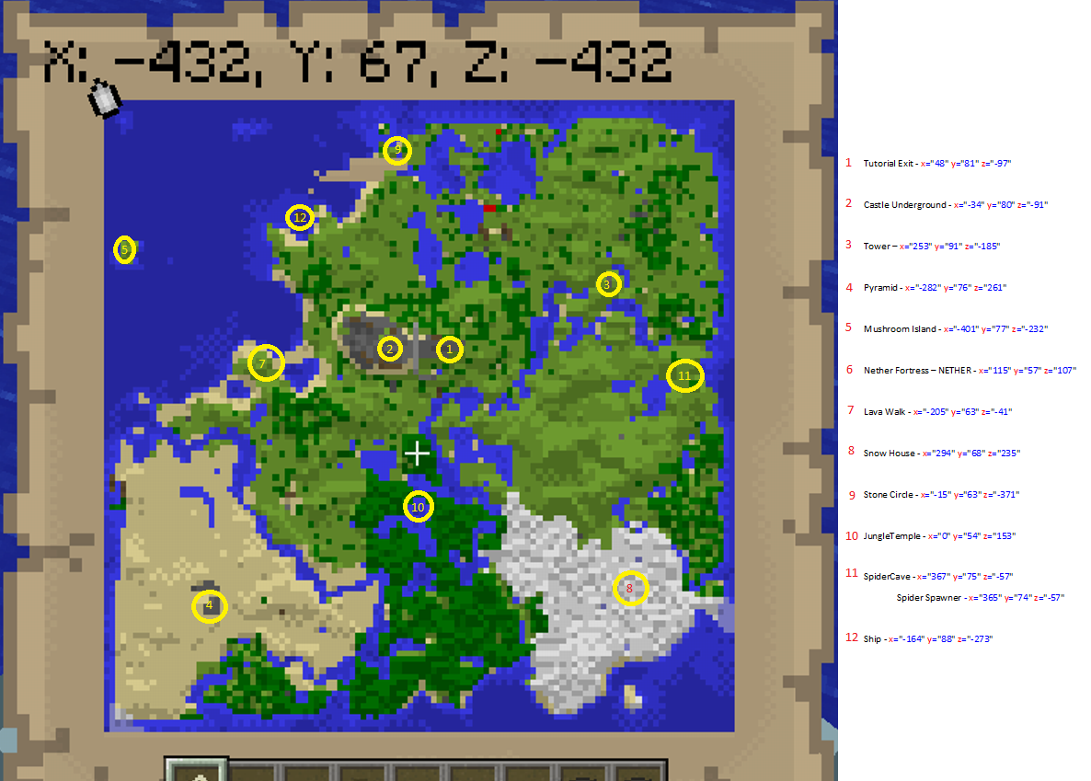

We’ve also added a Spider Spawner at - x="365" y="74" z="-57"

How To Play Additions

No changes

What’s New

The “What’s New” section will be changed to reflect all the 1.2.3 features.

Changes, Additions & Fixes

New Mobs

- Ocelot/Cat
- Iron Golem
- Baby Villager

New Items

- Redstone Lamp
- Jungle Wood Stairs
- Jungle Wood Half Slab
- Jungle Wood Block
- Jungle Wood Planks
- Jungle Tree Sapling
- Ocelot Spawn Egg
- (Creative Mode only) Chiselled Stone Brick
- (Creative Mode only) Mob Heads (Skeleton, Wither Skeleton, Zombie, Human and Creeper)

Changes/Additions

- New Tutorial World.
- New map height limit (256 instead of 128).
- Jungle Biome
- Jungle trees
- Cocoa beans grow on Jungle trees
- Slabs and Stairs can be placed upside-down by placing them below a block.
- Added Corner Stairs and upside down Corner Stairs.
- Added 3D dropped items.
- Added dispensing Boats and Minecarts to Dispenser.
- New ambient cave sounds.
- New AI for Mobs.
- Added rare drops for Mobs.
- Villagers will have children if there is room in their village.
- Zombie sieges will occur occasionally at night.
- Zombies break down doors on Hard Mode.
- Crafting recipe for ladder now yields 3 ladders instead of 2.
- Placing blocks on grass will replace it.
- Lava now has a faint rumbling sound effect, and large particles that hop out of the lava produce a popping sound.
- Very rare Desert Wells can be found in Desert biomes.
- Increased max boats in a world to 40.
- When in the Nether, Snow Golems will melt and die same as when they are in Desert biomes.
- Abandoned Mineshafts can generate with wooden bridges now when generated over a cave or over top another tunnel.
- Doors have been updated so that double doors work better with Redstone.
- Added a Favourites tab to the Skin Selector menu, storing most recently used skins.
- Added support for Texture Packs and Mash-up Packs, and display of these in the Minecraft Store.

Fixes

- Fixed local player shadows not being displayed.
- Fixed a few issues with the Privileges settings.
- Fixed visible seams in clouds.
- Fixed 3rd person camera issues with water, where the underwater filter would be randomly removed.
- Fix for structures generating at the edge of a world.
- Fix for putting enchanted items in a Minecart With Chest and destroying it removes the enchantments.
- Fix for breaking a bow having improper animation.
- Fix to make Minecarts run at the correct speed.
- Fixed a few memory leaks.
- Fixed issue with “Can Open Containers” option.
- Fixed issues with “Can Build and Mine” option.
- Fixed Issue with TNT blocks being triggered by explosions even with “TNT explodes” option off.
- Fixed Wolves not tilting their heads when the player has a bone in their hand.
- Fixed the colour of Potion particles status effect to match the Potion colour.
- Fix for doors spitting in half and glitching in open/closed motion when mined.
- Fixed artefacts on edge of flames when in first person.
- Fixed a lot of game lighting issues.

Create World

We’ll be adding the new terrain features from the Java version.

Terrain Generation Features

The terrain generation with 1.2.3 adds the following new features:-

- Jungle Biome
- Desert Wells

Desert Wells

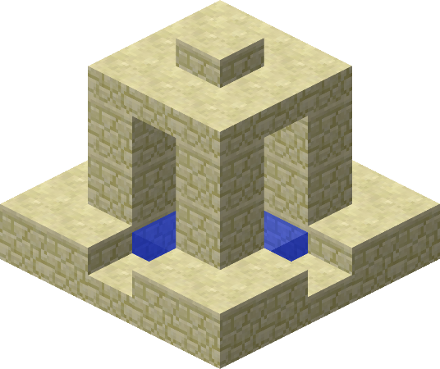

These well-like structures built of sandstone blocks and slabs generate only in the desert biome.

Jungle Biome

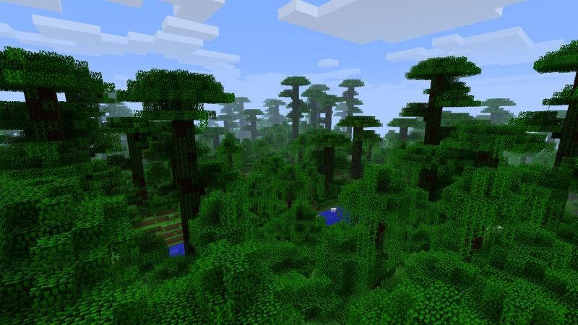

A very dense, tropical biome. It features large jungle trees that can reach up to 31 blocks tall with 2×2 trunks. Oak trees are also common. The landscape is lush green and quite hilly, with many small lakes of water often nestled into deep valleys, sometimes above sea level. Leaves cover much of the forest floor—these "bush trees" have single-blocks of jungle wood for trunks, surrounded by oak leaves for foliage. When inside a jungle, the sky will become noticeably lighter. This is the only biome containing ferns and the aforementioned jungle trees. Vines are found alongside most blocks and may be found close to the surface in caves. Ocelots, Jungle Temples and Cocoa Plants spawn exclusively in this biome, the latter found on jungle trees.

